Report of Lab 2

Zetao Zhu

zxz690@case.edu

1. **Edison Bluetooth part:**
2. Edison board

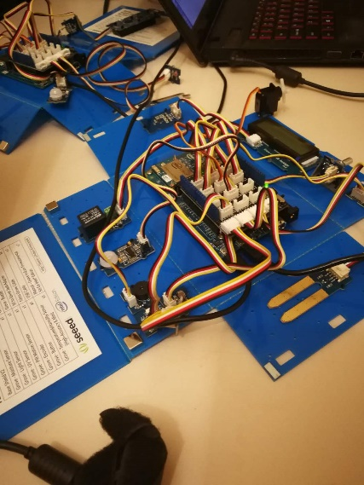

Write in sd.

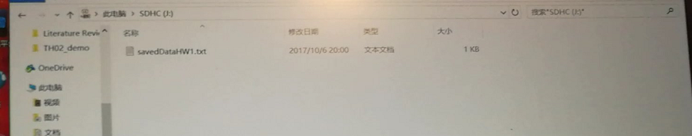

UI

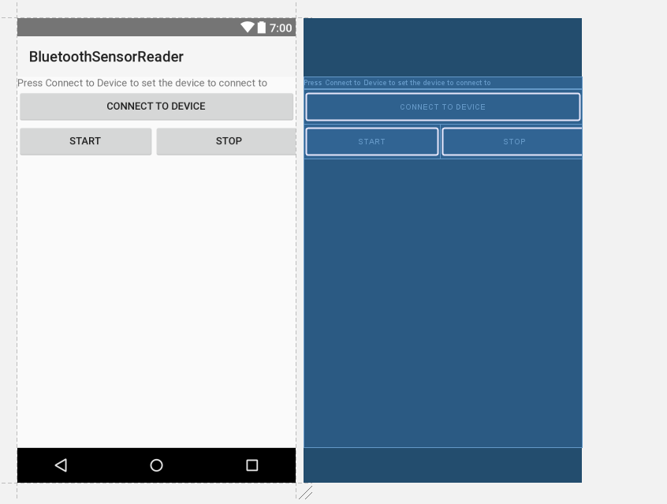

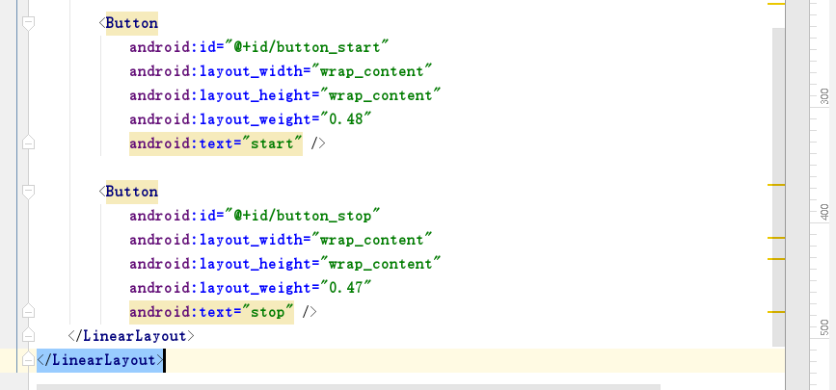

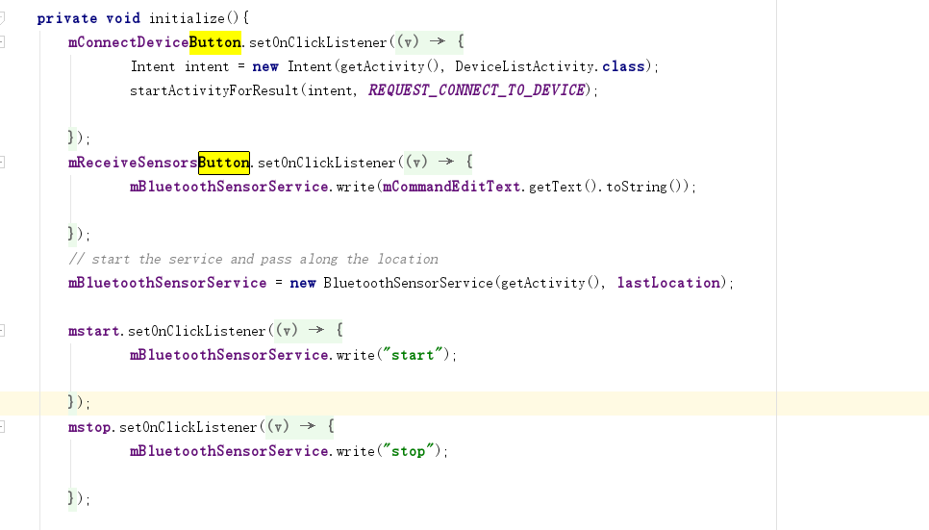

1. Android:

Connect to Bluetooth device by BluetoothSensorService

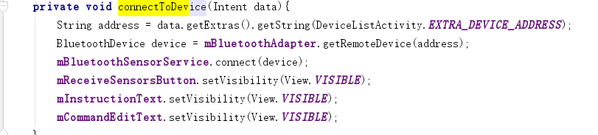

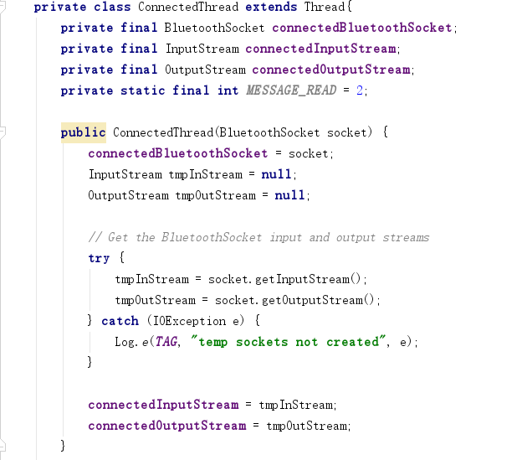

Maintain the connection and data link by way of thread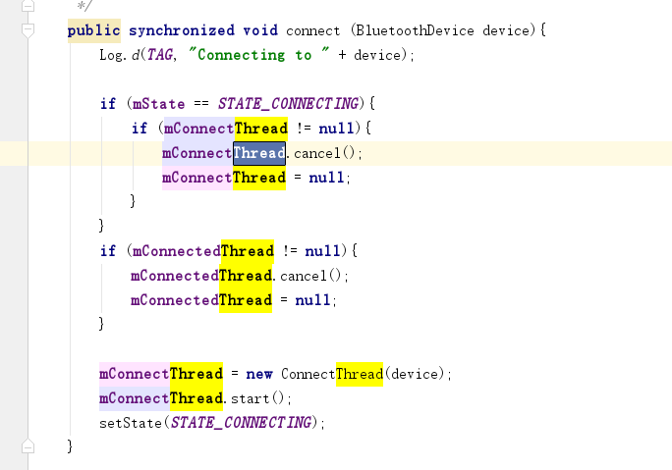

Send message to Edison.

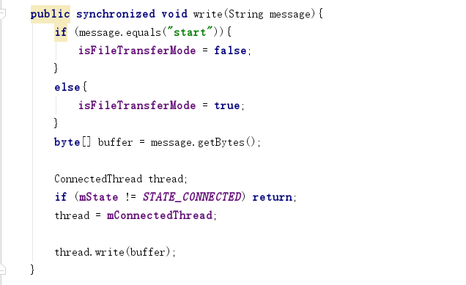

Make a connection to the BluetoothSocket

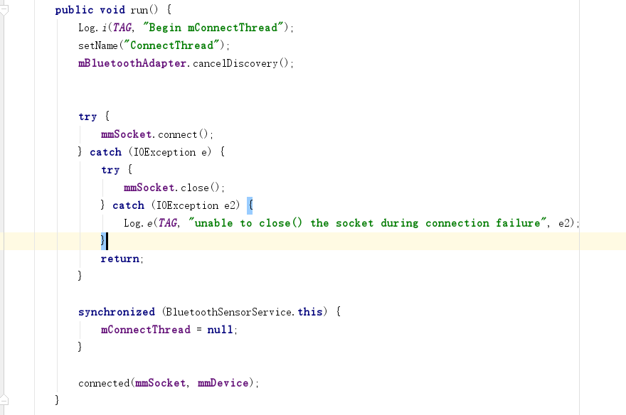

Check whether the csv.file exist or not

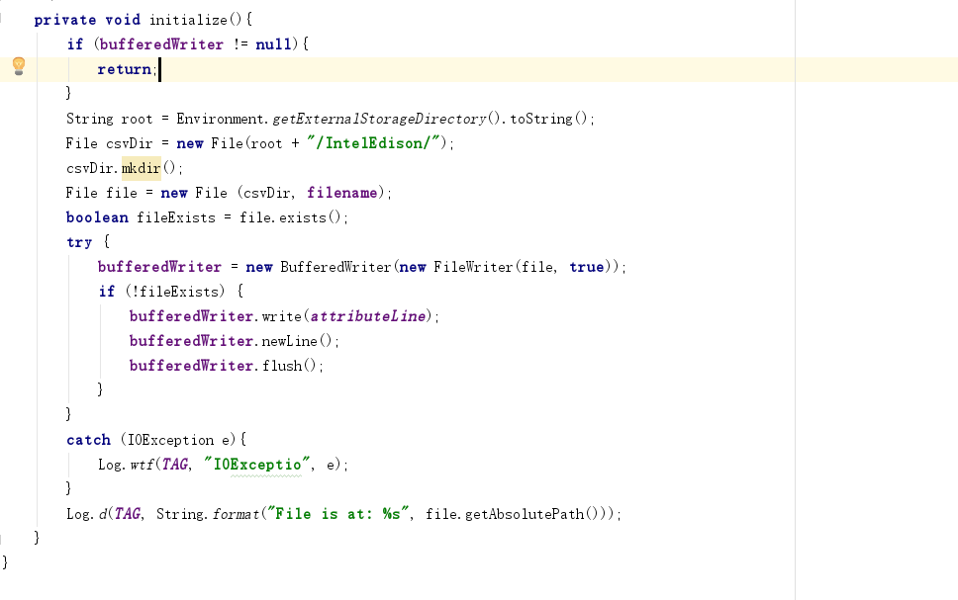

Listen Inputstream and write CSV

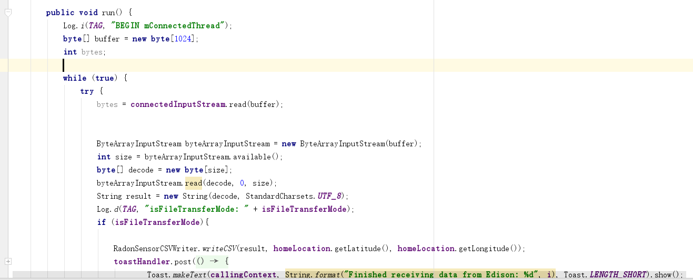

.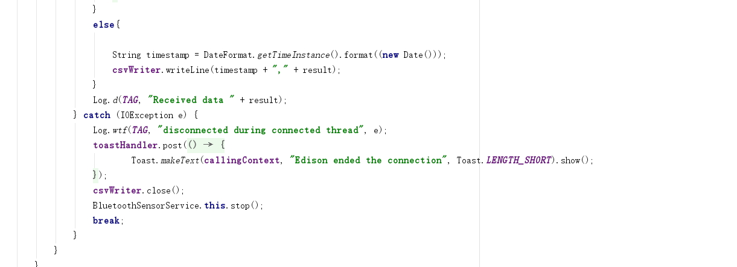

Write to the outstream

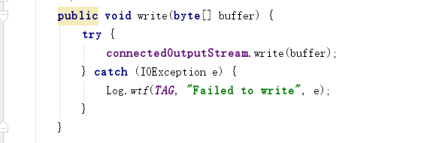

1. Python:

The code we have modified in python.

Import pyupm_th02 as th

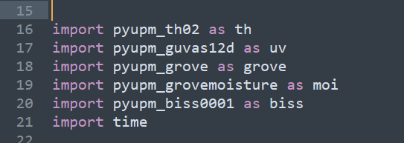

I nitializing the sensor and getting data

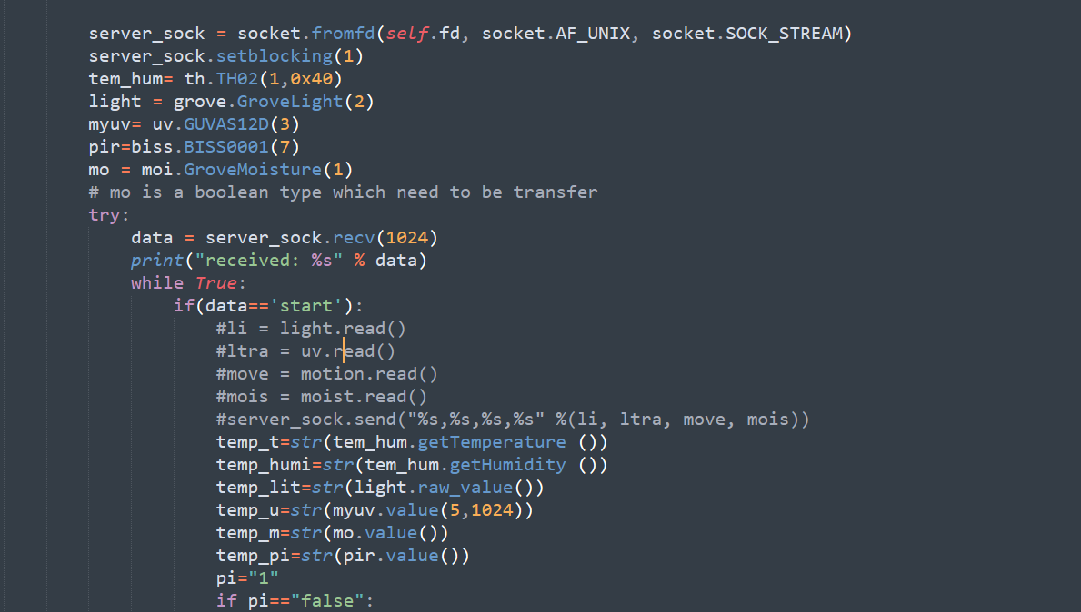

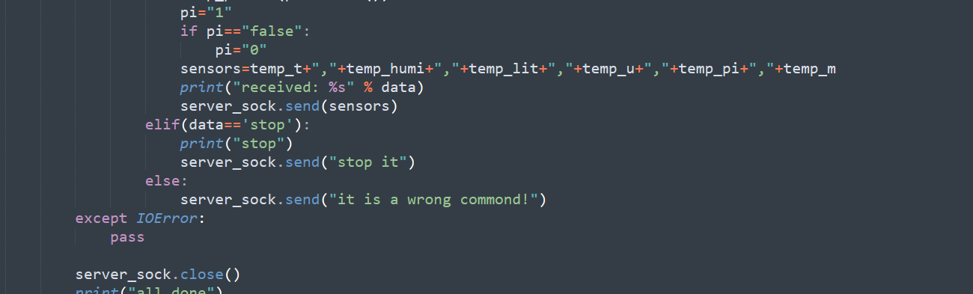

1. In the Android Things part:

1）setup “Bluetooth GATT Server”,

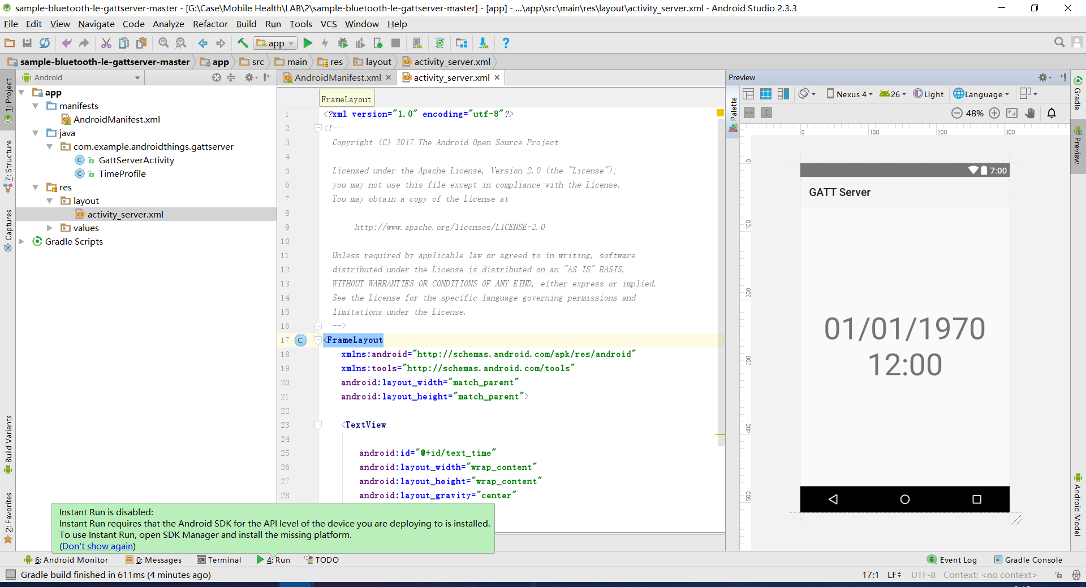

2）show current time service

